Z-number Cloud Modelling Algorithm Step-by-Step Execution Program Operation Manual
Document Version: V1.0
Last Updated Date: 2024-10-27
Corresponding Program Version: V1.0
LabVIEW Version: NI LabVIEW 2020 (32-bit)
Author: Xinyu Liu

1. Document Overview

1.1 Purpose
This document aims to guide users on how to correctly and orderly operate the step-by-step algorithm program written in LabVIEW. By following the process specified in this manual, users can complete the entire process from data preparation, parameter configuration, step-by-step execution to result analysis, and obtain the expected algorithm operation results.

1. Important Reminder
- Execution order is crucial! Please be sure to execute each sub-VI strictly in the sequence specified in Chapter 5: Step-by-Step Operation Process. Incorrect execution order may lead to calculation errors or program exceptions.
- Before starting operation, please ensure you have read Chapter 3: Environment and Preparation in detail.

2. Program Structure Description
This program consists of a series of independent sub-VIs (LabVIEW Virtual Instruments) that work together to complete the Z-number cloud modelling algorithm. The core modules include:
1. Finding fuzzy number by center of gravity.vi
2.1 – 2.3 Calculate the expert consistency.vi
3.1 – 3.2 Calculate expert reliability.vi
4. The combined weight.vi
5.1 Calculation attribute weighting formula（uk.Zijk).vi
5.2 Calculation attribute weighting formula（Zij^）.vi
5.3 Calculation attribute weighting formula（Zij—）.vi
5.4 Calculation attribute weighting formula（ej）.vi
5.5 Calculation attribute weighting formula（nj）.vi
6.1 The integrated cloud decision information matrix .vi
6.2 The integrated cloud decision information matrixCDC.vi
7. The cloud dominance degree .vi
8. The combined decision value of the scheme wi.vi
Data Flow Description:
Execute sequentially according to the above program order from 1 to 8. The output data from the previous VI is saved as a .txt file, which serves as the input data for the next VI. Finally, the corresponding calculation results can be obtained. Please check the data results generated at each step in the Results folder.
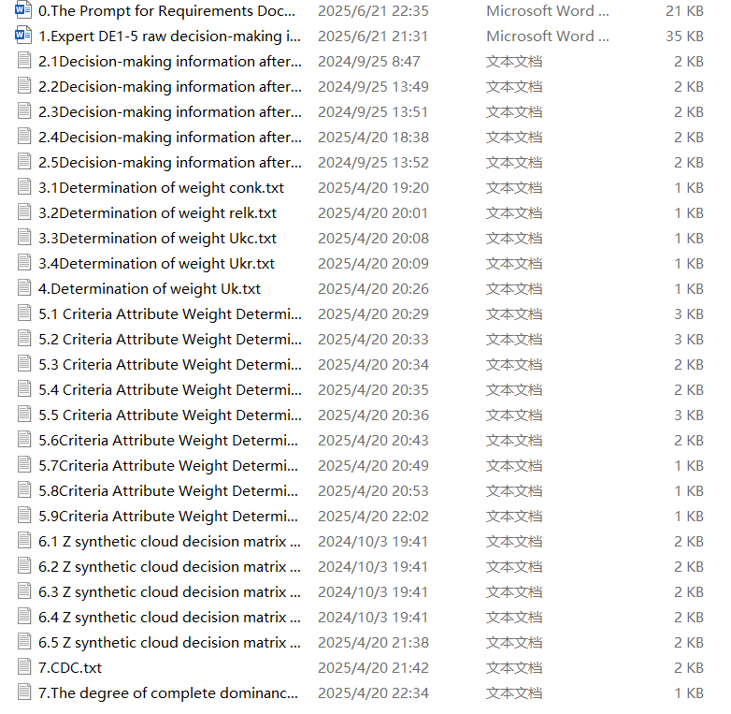

3. Environment and Preparation

3.1 Software and Hardware Requirements
- Operating System: Windows 10/11 (32-bit)
- Software: NI LabVIEW 2020 (32-bit)
- Other Dependencies: NI-VISA Driver

3.2 File Preparation
- Unzip the The code and results program package.
- Confirm the program directory structure is complete, which should typically include:
  - The code folder: Stores all sub-VI files.
  - Results folder: Stores output data files.

4. Step-by-Step Operation Process
Step 1:
- Open 1. Finding fuzzy number by center of gravity.vi in LabVIEW.
- Click the "Run" button on the toolbar. This will run and yield the result corresponding to Equation 11 in the paper.
- Save the result as a .txt file to be used as input data for the next step.
- Close this sub-VI.
Step 2:
- Open 2.1 Calculate the expert consistency.vi in LabVIEW.
- Click the "Run" button on the toolbar. Input its resulting data into 2.2 Calculate the expert consistency.vi.
- This will run and yield the result corresponding to Equation 13 in the paper.
- Save the result as a .txt file to be used as input data for the next step.
- Close this sub-VI.
Step 3:
- Open 2.3 Calculate the expert consistency.vi in LabVIEW.
- Enter the k values sequentially from 1 to 5, clicking the "Run" button each time. This will run and yield the result corresponding to Equation 15 in the paper.
- Save the result as a .txt file to be used as input data for the sixth step.
- Close this sub-VI.
Step 4:
- Open 3.1 Calculate expert reliability.vi in LabVIEW.
- Click the "Run" button on the toolbar. This will run and yield the result corresponding to Equation 17 in the paper.
- Save the result as a .txt file to be used as input data for the next step.
- Close this sub-VI.
Step 5:
- Open 3.2 Calculate expert reliability.vi in LabVIEW.
- Enter the k values sequentially from 1 to 5, clicking the "Run" button each time. This will run and yield the result corresponding to Equation 18 in the paper.
- Save the result as a .txt file to be used as input data for the sixth step.
- Close this sub-VI.
Step 6:
- Open 4. The combined weight.vi in LabVIEW.
- Use the output results from the third and fifth steps as input for this step, and click the "Run" button. This will run and yield the result corresponding to Equation 19 in the paper.
- Save the result as a .txt file to be used as input data for the next step.
- Close this sub-VI.
Step 7:
- Open 5.1 Calculation attribute weighting formula (uk.Zijk).vi in LabVIEW.
- Click the "Run" button on the toolbar. Input its resulting data into 5.2 Calculation attribute weighting formula (Zij^).vi.
- This will run and yield the result corresponding to Equation 20 in the paper.
- Save the result as a .txt file to be used as input data for the ninth step.
- Close this sub-VI.
Step 8:
- Open 5.3 Calculation attribute weighting formula (Zij---).vi in LabVIEW.
- Enter the j values sequentially from 1 to 7, clicking the "Run" button each time. This will run and yield the result corresponding to Equation 21 in the paper.
- Save the result as a .txt file to be used as input data for the ninth step.
- Close this sub-VI.
Step 9:
- Open 5.4 Calculation attribute weighting formula (ej).vi in LabVIEW.
- Use the output results from the seventh and eighth steps as input for this step, enter the j values sequentially from 1 to 7, clicking the "Run" button each time. This will run and yield the result corresponding to Equation 22 in the paper.
- Save the result as a .txt file to be used as input data for the next step.
- Close this sub-VI.
Step 10:
- Open 5.5 Calculation attribute weighting formula (nj).vi in LabVIEW.
- Enter the j values sequentially from 1 to 7, clicking the "Run" button each time. This will run and yield the result corresponding to Equation 23 in the paper.
- Save the result as a .txt file to be used as input data for the next step.
- Close this sub-VI.
Step 11:
- Open 6.1 The integrated cloud decision information matrix .vi in LabVIEW.
- Click the "Run" button on the toolbar. Input its resulting data into 6.2 The integrated cloud decision information matrixCDC.vi.
- This will run and yield the result corresponding to the integrated cloud decision information matrix CDC in the paper.
- Save the result as a .txt file to be used as input data for the next step.
- Close this sub-VI.
Step 12:
- Open 7. The cloud dominance degree .vi in LabVIEW.
- Click the "Run" button on the toolbar. This will run and yield the result corresponding to Equation 29 in the paper.
- Save the result as a .txt file to be used as input data for the next step.
- Close this sub-VI.
Step 13:
- Open 8. The combined decision value of the scheme wi.vi in LabVIEW.
- Click the "Run" button on the toolbar. This will run and yield the result corresponding to Equation 30 in the paper.
- Save the result as a .txt file.
- Close this sub-VI.
Wish you smooth use!

